# 5.1  Company Overview – DHL Group

DHL Group—the logistics arm of Deutsche Post—operates the world’s largest contract‑logistics and express‑parcel network, handling roughly 1.8 billion parcels and 50 million freight shipments annually across 220 countries.¹ Its supply‑chain architecture is a multi‑echelon web of air hubs, ocean gateways, cross‑dock mega‑centres and more than 350 smart warehouses equipped with autonomous mobile robots (AMRs), automated guided vehicles (AGVs) and vision‑guided sortation.² The Group’s “Strategy 2025” rests on two pillars: digitalisation and decarbonisation. Digitalisation earmarks more than €2 billion for warehouse robotics, IoT sensorisation and the in‑house Resilience360 risk‑predictive platform; sustainability targets a 42 percent cut in scope‑1 & 2 emissions and 60 percent electric last‑mile vehicles by 2030.³

Financially, top‑line growth averaged 2.9 percent CAGR from 2015 to 2024, with an e‑commerce‑fuelled spike during the COVID‑19 demand shock (Figure 1). Express and eCommerce Solutions together now generate over half of revenue, while the Supply Chain division—home to most Industry 4.0 pilots—contributes roughly one fifth. Operating margin improved from 6.0 percent to 8.2 percent over the decade, attributed by management to automation and data‑driven route optimisation.⁴

The physical footprint includes five global air hubs (Leipzig, Cincinnati, Hong Kong, Panama and Bahrain), 16 regional mega‑hubs and a fleet of 570 aircraft. Warehousing space exceeds 13 million m², of which 40 percent is covered by automated storage and retrieval systems (AS/RS). Total headcount stands near 600 000 FTEs—large enough to require sophisticated change‑management programmes whenever new automation is introduced.

Table 1 summarises headline statistics that frame the adoption chronology (§ 5.2) and quantitative analysis (§ 5.3). These indicators position DHL as a data‑rich exemplar for exploring how large‑scale logistics networks operationalise Industry 4.0 while pursuing aggressive decarbonisation targets.

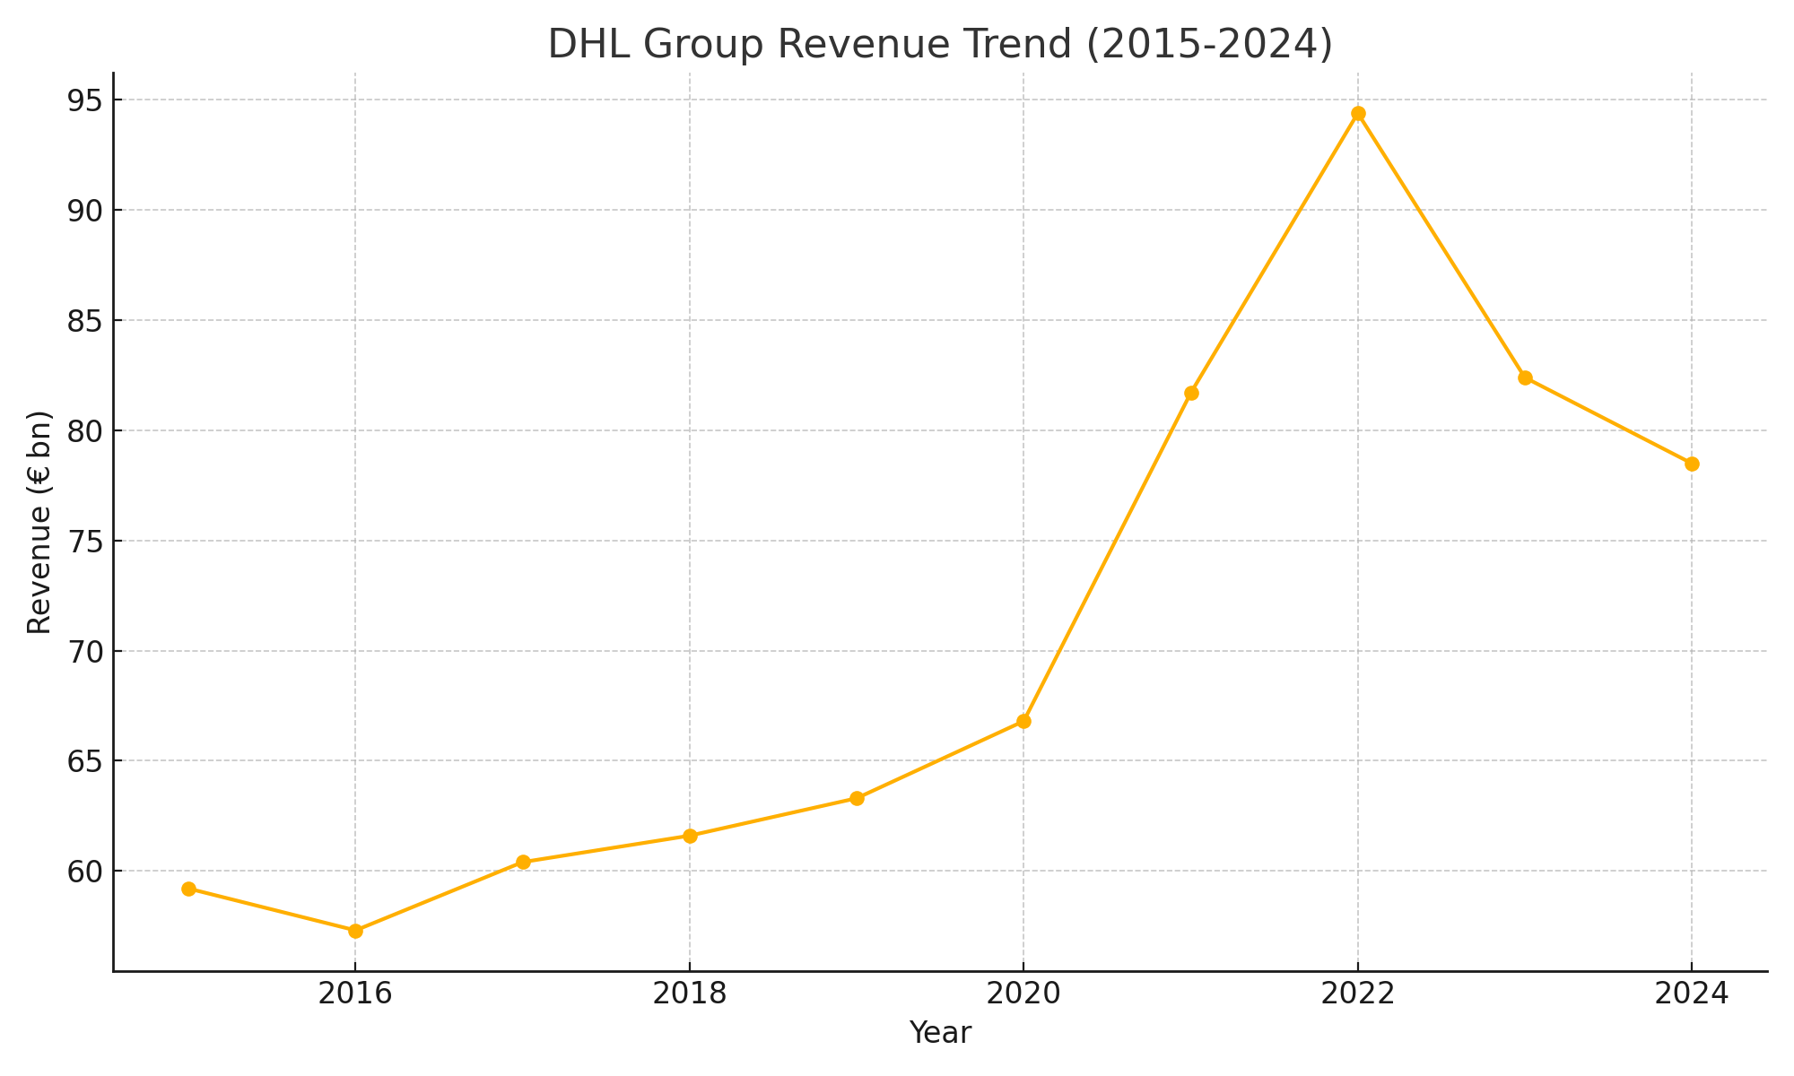

|  |  |
| --- | --- |
| Metric | Value |
| Revenue (FY 2024) | € 78.5 bn |
| Operating margin | 8.2 % |
| Employees (FTE) | ≈ 600 000 |
| Smart warehouses | 350 + |
| Parcels handled | 1.8 bn |
| Scope‑1 & 2 CO₂e | 23.4 Mt |

## Footnotes

1. DHL Group, *Annual Report 2024* (Bonn: Deutsche Post DHL Group, 2025), 18, https://www.dhl.com/content/dam/dhl/global/core/documents/pdf/dpdhl-annual-report-2024.pdf.

2. DHL Group, *Operations 4.0 Report 2024* (Bonn: DHL, 2024), 6–9, https://www.dhl.com/content/dam/dhl/global/core/documents/pdf/dhl-operations-4-0-report-2024.pdf.

3. Deutsche Post DHL Group, “Strategy 2025 – Delivering Excellence in a Digital World,” investor presentation, March 2024, https://www.dpdhl.com/en/investors/strategy-2025.html.

4. DHL Group, *Annual Report 2024*, 45.